# Exploring the Cosmic Microwave Background with CAMB

## J. Christiansen

### Department of Physics

### California Polytechnic State University

### San Luis Obispo, CA

## 7 December 2010

By now you will have studied the Cosmic Microwave Background and its features in class. This project is intended to introduce you to an online tool that simulates the cosmic microwave background in any universe of your choosing. It includes a calculator that determines physical quantities much like the one that you created in the project “*Computing the Expansion History of the Universe*”. In addition, it computes the evolution of density fluctuations in the early universe. By creating universes different than our own, you should develop a better understanding of the process scientists used to measure the parameters of our universe.

Before going further, I have to tell you that this project is truly remarkable. The online tools that we will be using are still used routinely in sophisticated research. These are not watered down, out of date, has beens. It is part of NASA’s commitment to education and outreach that the Code for Anisotropies in the Microwave Background (CAMB) [2] and CMBFAST [3] programs have been packaged to run on a server with a web interface that we can access.

#### Before you start

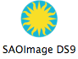You’ll need to install a FITS file viewer on your computer. FITS is pretty much every astronomer’s favorite file format. The acronym stands for Flexible Image Transport System. And unfortunately, CAMB distributes its information in these files. To view them you’ll need to download a free FITS viewer: <http://heawww.harvard.edu/RD/ds9/>. Version 6.2 didn’t work on my machine so I recommend downloading the Version 6.1 binary for your operating system. Just click on the link and save it somewhere on your computer. When it’s on your computer double click on it and an “install” window will open. Drag the sun icon onto your desktop or into your applications folder. When you click on the SAOimageDS9 icon, the FITS viewer will open. If it doesn’t work try downloading a different version. An example FITS data file is on our course web page. <http://astro.calpoly.edu/jodi/W11Phys326/>You can click on the FITS file, but it won’t look like much. Download the file by right clicking on the link and then “Save link as…”. Open the file in DS9 and make sure that you’re seeing an image. When DS9 is working properly, you’re ready to start the project.

## Part 1 – Simulating CMB Maps

Lets say that you throw a pair of dice 1000 times. On average you expect the face on each die to appear an equal number of times. Each time you throw the die, however, you get one result. We call a specific outcome of a probabilistic system a realization. In cosmology, we have one universe and we can’t repeat the experiment. This is what makes it an observational science instead of an experimental science. Sometimes it feels like an experiment if we look at a large number of galaxies, but in reality, we can’t turn a single galaxy around to look at the other side and we can’t make new ones. We have to live with the view we are given.

The map of the temperature fluctuations in the cosmic microwave background is shown in Figure 1. These are the fluctuations in the *observed* universe. We can’t change them, look from another vantage point, or go to another universe to repeat the experiment. This is the result and all we can do is pull the statistical information out of this view.

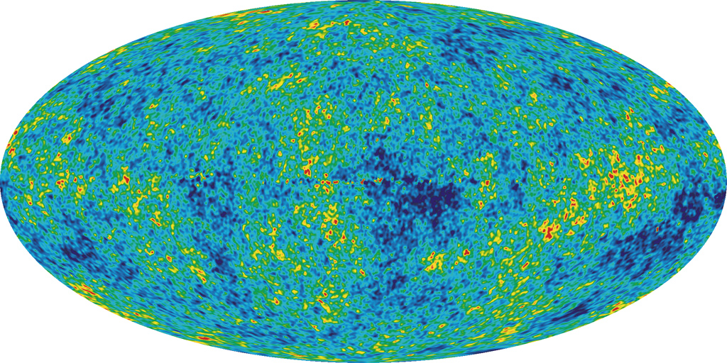

Figure : WMAP 5-year ILC map [1]

Although there is only one real universe, we can use probability to simulate as many universes as we like and pretend to do the observation many times. We will do this with CAMB, the central engine of this was originally written by Seljak and Zaldarriaga [2] the authors of this version are Lewis and Challinor [3]. These are highly respected theorists who specialize in cosmology. You can access it by clicking on the following link. http://lambda.gsfc.nasa.gov/toolbox/tb_camb_form.cfm

To generate a sky map, you need to change the setting, Sky Map Setting, to output a Temperature map. If you’re interested in the Polarization map it can make that too. Change the beam‐size parameter to about 60 arcmin.

Take a look at the available options. You should recognize some of the lingo by now. Some of the options on this page, however, are beyond the scope of this course.

Find the section labeled Cosmological Parameters. Change the option, Use Physical Parameters to no. This will give you the now familiar Omega Parameters. Lets use the 7‐year WMAP parameters from reference [4]. We used these same parameters in Project #1. Don’t worry about the options you don’t recognize. They have reasonable values and are set to govern some of the thermodynamic models that are beyond the scope of this course. When everything is set, you can hit return or the go button at the bottom of the page. It takes a little bit of time to generate the map, but since this is what we’re interested in, it’s well worth the wait.

Verify that the results make sense when they pop up. Based on your previous project, what do you expect the age, distance to the horizon (called tau‐Now), Ωm, Ω0 and Ωk to be? Do the values computed by CAMB make sense?

Part way down the page is a “Molleweid Sky Map” in FITS format. You can view it in place or download it and then view it. Open the Sky Map that you created. You’ll want to size it to the frame using the zoom 1/4 option. You’ll also want to use a color scheme similar to the one the WMAP people use. Click on scale and then squared and minmax to up the contrast some. Then click on color and choose rainbow for the color scheme. Go ahead and spend a few minutes checking out the viewer.

This is similar to the WMAP scheme, except it doesn’t have enough grey in it. Unfortunately I don’t know how to add grey. WMAP also doesn’t have purple at the bottom of the scale. To remove the purple, you’ll need to adjust the color parameters. There are more options in the bar at the top of the screen than in the bubbles on the viewer. Click on color and select Color Parameters. Adjusting the bias to down to 0.4 and the contrast down to 0.97 or 0.93 removes the purple.

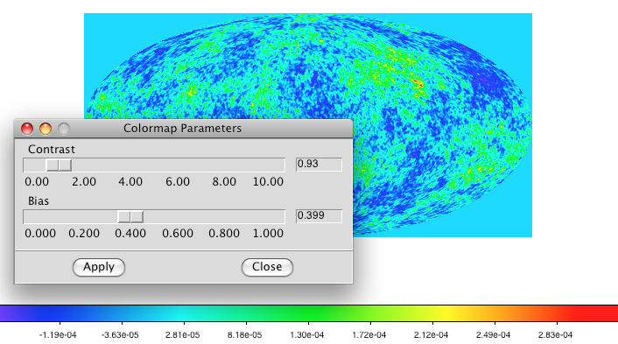

Figure : Setting the colormap parameters

**Report:** Run the simulation 4 times and include screen shots of the images in your report. Describe how the character of the spots doesn’t change even though the pictures are completely different from one another.

Verify that the CAMB results make sense based on your previous project. Do the age, distance to the horizon (called tau‐Now), Ωm, Ω0, and Ωk agree?

Now check out a low‐density universe. Set Ωcdm and ΩLambda to zero. Do the spots look like they did before? Comment on any differences you observe. Which plots most closely resemble the observed WMAP sky map shown in Figure 1?

## Part 2 – Finding Cosmological Parameters from the Power Spectrum

A Power Spectrum is a good way to pull statistical properties out of under‐sampled or noisy data. Instead of matching specific bright or dark patches or regions in the sky map, the power spectrum categorizes the amount (or power) of each size patch. Technically this is done by decomposing the sky into Spherical Harmonics which are the *Ylm* functions of quantum mechanics. The normalization coefficients, *Cl*, are scaled by *l(l+1)* and then plotted as a function of *l*, the harmonic number. The WMAP power spectrum is shown in Figure 3. How does the top panel compare to a CAMB simulation of the power spectrum?

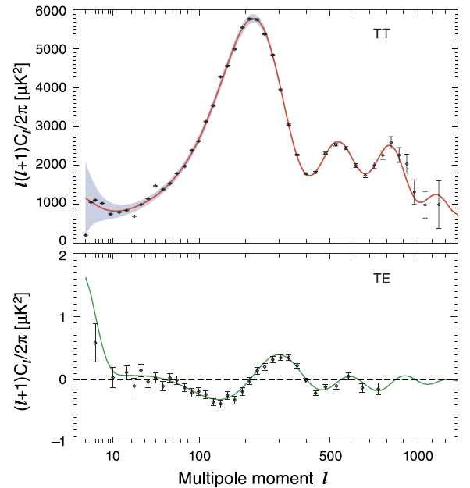

Figure : WMAP power spectrum (top) temperature, (bottom) TE

**Report:**

1. Run the program multiple times with the same parameter settings. You have seen that the maps change every time you run the program. Explain any changes you observe in the power spectra between different runs. Is the power spectrum insensitive to specific realizations?
2. Lets look at the power spectrum for our favorite parameter settings. Take a screen shot of a sky map, and the TT and TE power spectra to include in your report. Record the parameters, age, and tau_now while you’re at it.

Benchmark

Einstein‐deSitter

Low‐Density, Matter‐Only

WMAP

Which power spectrum most closely resembles the real WMAP data? You’ll have to look carefully because the CAMB scale is linear and the WMAP scale is logarithmic. This can be done with some numerical precision, however.

1. To really understand the sensitivity of the Power Spectrum, you need to explore what each Omega parameter contributes. (You can turn off the map making to speed this part up.)
   1. Normal (baryonic) Matter Only: turn off all the other parameters. Slowly increase the baryonic matter from a small value ~0.05 to a large value like 1.2. Sketch the features in the spectrum and how they change as the universe gets denser. Describe the main features that you can attribute to matter.
   2. Add Dark Matter: CAMB won’t run unless there are baryons for the photons to interact with. Set Omega matter to about 0.05. Raise the dark matter contribution from 0 to 1.2 and characterize the spectrum. Again, sketch the features in the spectrum and how they change as the universe gets denser with dark matter. Describe the main features that you can attribute to dark matter.

You should have noticed that the primary peak moves to the left as the density goes up. The primary peak is at *l* = 200 in the WMAP data. How much matter does it take to move the peak to *l* = 200? Does it matter if its normal or dark matter? From your investigation, is there any evidence that the universe contains dark matter?

* 1. Dark Energy: Set the baryonic matter to 0.05. Increase the dark energy from 0 to about 1.2. Sketch and then describe the features and how they change as dark energy is added.
  2. See if you can find a set of parameters that is different from the WMAP parameters, but which still does a pretty good job of describing the spectrum.

Please comment on whether this exercise was helpful for understanding that the measurements are uniquely described by the WMAP parameters, which provide strong motivation for dark matter and dark energy.

## References:

1. WMAP collaboration, <http://map.gsfc.nasa.gov/news/5yr_release.html> Downloading the 5.77 MB image will be quite rewarding.
2. U. Seljak and M. Zaldarriaga, *A Line-of-Sight Integration Approach to Cosmic Microwave Background Anisotropies*, ApJ, **469**: 437‐444, (1996). <http://arxiv.org/abs/astro-ph/9603033>.
3. CAMB, <http://camb.info/>.
4. WMAP collaboration, *Seven-Year Wilkinson Microwave Anisotropy Probe Observations: Sky Maps, Systematic Errors, and Basic Results*, (2011), ApJS, **192**, 14 <http://arxiv.org/abs/1001.4744>